**Features to be tested**

1. **Login:** Testing the login feature when logging in to Canvas at <https://sjsu.instructure.com/> utilizing a SJSU ID Number and Password
2. **Password Reset:** Testing the password reset feature, by pressing “Reset my Password” on the aforementioned link to the SJSU Canvas login page
3. **Submit assignment:** Testing the submit assignment feature where the user tries to submit the correct format, incorrect formats, past-due assignments, etc.
4. **Comment on a (un)graded assignment, project or exam:** After submitting an assignment, project or after taking an exam, the student, grader or teacher can comment on the submission. This test is to ensure after the user

**Testing Environment**

Test environments should consist of a browser in multiple environments. For example, mobile should be tested versus on a desktop. And different browsers should be considered, such as: chrome, firefox, edge, safari, opera, etc.

**Login Feature Testing**

**Input Domain:**

Student ID: Text inputs including letters, numbers, and symbols

Password: Text inputs including letters, numbers, and symbols

**Equivalence Partitions/ Boundary Values:**

NA

**Test Cases:**

|  |  |  |  |  |  |  |
| --- | --- | --- | --- | --- | --- | --- |
| Test Case # | Test Steps | Student ID (Input) | Password (Input) | Expected Output | Actual Output | Result (Pass/Fail) |
| 1 | 1. Enter valid SID  2. Enter valid password  3. Click login button | 264853197 | validPass1? | Successful login | Successful login | Pass |
| 2 | 1. Enter valid SID  2. Enter invalid password  3. Click login button | 234865972 | invalidPass1? | Unable to sign in | Unable to sign in | Pass |
| 3 | 1. Enter invalid SID  2. Enter valid password  3. Click login button | 5648213 | validPass1? | Unable to sign in | Unable to sign in | Pass |
| 4 | 1. Enter invalid SID  2. Enter invalid password  3. Click login button | 3248516 | invalidPass1? | Unable to sign in | Unable to sign in | Pass |
| 5 | 1. Leave SID and password fields blank  2. Click login button |  |  | We found some errors. Please review the form and make corrections | We found some errors. Please review the form and make corrections | Pass |

**State Transition Diagram:**

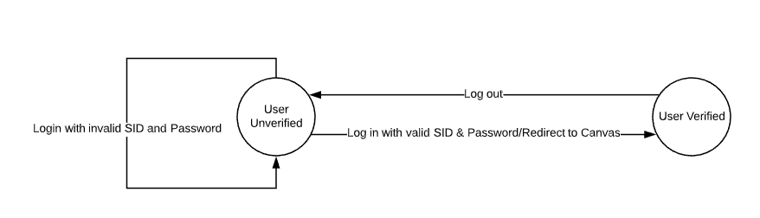

**Log In UI:**

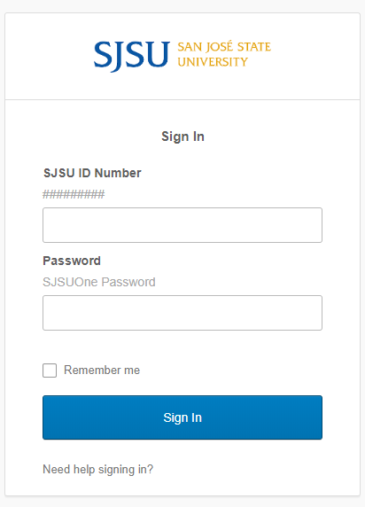

**Password Reset Feature Testing**

**Input Domain:**

Password: Text inputs including letters, numbers, and symbols

**Equivalence Partitions/ Boundary Values:**

NA

**Test Cases:**

|  |  |  |  |  |  |  |
| --- | --- | --- | --- | --- | --- | --- |
| Test Case # | Test Steps | Description | Password (Input) | Expected Output | Actual Output | Result (Pass/Fail) |
| 1 | 1. Enter password  2. Confirm Password  3. Click Continue | Valid password with 10-16 characters | Password54? | Password changed successfully | Password changed successfully | Pass |
| 2 | 1. Enter password  2. Confirm Password  3. Click Continue | Vald password with 17-28 characters | testInputPassword2 | Password changed successfully | Password changed successfully | Pass |
| 3 | 1. Enter password  2. Confirm Password  3. Click Continue | Non-unique password | pastPass16? | Please enter valid password | Please enter valid password | Pass |
| 4 | 1. Enter password  2. Confirm Password  3. Click Continue | Password with spaces | Pass word16? | Please enter valid password | Please enter valid password | Pass |
| 5 | 1. Enter password  2. Confirm Password  3. Click Continue | Password with no lowercase letters | PASSWORD32! | Please enter valid password | Please enter valid password | Pass |
| 6 | 1. Enter password  2. Confirm Password  3. Click Continue | Password with no capital letters | password32! | Please enter valid password | Please enter valid password | Pass |
| 7 | 1. Enter password  2. Confirm Password  3. Click Continue | Password with no numbers | Password! | Please enter valid password | Please enter valid password | Pass |

**Decision Table:**

|  |  |  |  |  |  |  |  |  |  |  |
| --- | --- | --- | --- | --- | --- | --- | --- | --- | --- | --- |
| Condition | Value | R1 | R2 | R3 | R4 | R5 | R6 | R7 | R8 | R9 |
| Length between 10-28 | Y/N/- | N | Y | Y | Y | Y | Y | Y | Y | Y |
| Length between 17-28 | Y/N/- | - | Y | Y | N | N | N | N | N | N |
| Contains no spaces | Y/N/- | - | - | - | N | Y | Y | Y | Y | Y |
| Contains at least one lower case letter | Y/N/- | - | - | - | - | N | Y | Y | Y | Y |
| Contains at least one capital letter | Y/N/- | - | - | - | - | - | N | Y | Y | Y |
| Contains at least one number | Y/N/- | - | - | - | - | - | - | N | Y | Y |
| Unique from past passwords | Y/N/- | - | N | Y | - | - | - | - | N | Y |
| **Effects** | | | | | | | | | |  |
| Password is approved |  |  |  | 1 |  |  |  |  |  | 1 |
| Password is rejected |  | 1 | 1 |  | 1 | 1 | 1 | 1 | 1 |  |
| **Checksum** | 128 | 64 | 16 | 16 | 16 | 8 | 4 | 2 | 1 | 1 |

**Password Reset UI:**

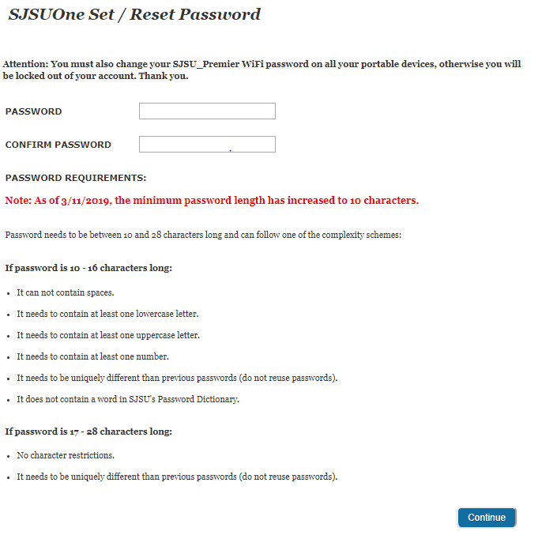

**Submit an assignment:**

**Input Domain:**

Course: must have a course assigned

File: File to be submitted for the assignment (e.g. PDF, PNG, DOCX, etc.)

**Equivalence Partitions / Boundary Values:**

N/A

**Test Cases:**

|  |  |  |  |  |  |  |  |
| --- | --- | --- | --- | --- | --- | --- | --- |
| Test Case # | Test Steps | Description | Course (Input) | File (input) | Expected Output | Actual Output | Result (Pass/Fail) |
| 1 | Login Select course & assignment that’s available to turn in Press the Submit button  Select a file to turn in that matches the submission criteria  Press “Submit Assignment” | Testing if a nominal case performs correctly. Only PDF accepted | CMPE-187 | Test.pdf | Course submitted without error | Course submitted without error | Pass |
| 2 | Login Select course & assignment that’s available to turn in Press the Submit button  Select a file to turn in that does not match the submission criteria  Press “Submit Assignment” | Testing if an assignment isn’t accepted for an incorrect filetype. Only PDF accepted | CMPE-187 | Test.png | Cannot select PNG as a filetype | PNG’s are grayed out and cannot be selected | Pass |
| 3 | Login Select course & assignment that’s available to turn in Press the Submit button  Select a file to turn in that matches the submission criteria  Press “Submit Assignment” | Testing if an assignment is not accepted late. Only PDF accepted. Late assignments lock submissions | CMPE-187 | Test.pdf | The submit button should not be available to press | Could not submit assignment, no submit button available | Pass |
| 4 | Login Select course & assignment that’s available to turn in Press the Submit button  Select a file to turn in that does not match the submission criteria  Press “Submit Assignment” | Testing if an assignment isn’t accepted if late and incorrect filetype. Only PDF accepted | CMPE-187 | Test.png | The submit button should not be available to press | Could not submit an incorrect filetype because the submit button was not available | Pass |
| 5 | Login Select course & assignment that’s available to turn in Press the Submit button  Select a file to turn in that matches the submission criteria  Press “Submit Assignment” | Testing if no assignment attached is accepted. Only PDF accepted | CMPE-187 | N/A | An error should be displayed saying a file upload is required | An error was shown saying a file must be submitted | Pass |

**State Transition Diagram:**

**UI:**

**Comment on (un)graded assignment, project or exam:**

**Input Domain:**

Course, Assignment: Course, Assignment pair (e.g. CMPE-187, Feature Testing)

Comment: Text, media or file

**Equivalence Partitions / Boundary Values:**

N/A

**Test Cases:**

|  |  |  |  |  |  |  |  |
| --- | --- | --- | --- | --- | --- | --- | --- |
| Test Case # | Test Steps | Description | Course, Assignment (Input) | Comment (input) | Expected Output | Actual Output | Result (Pass/Fail) |
| 1 | Login Select course and an assignment  Put text into the comment input field Press Save | Press save with text comment | CMPE-187, Feature Testing | “Test” | Comment shown under comment input field | Comment was appended under the input field | Pass |
| 2 | Login Select course and an assignment  Press the Media Comment, record the media Press Save | Media comment without any text | CMPE-187, Feature Testing | MP3 Recording | MP3 Recording shown under comment input field | MP3 Record is shown under the comment input field | Pass |
| 3 | Login Select course and an assignment  Put text into the comment input field  Press Attach file, and select a file to upload Press Save | Attach file with text | CMPE-187, Feature Testing | Test.pdf, “Test” | Comment and file shown under comment input field | Comment and file are shown under the comment input field | Pass |
| 4 | Login Select course and an assignment  Press Attach file, and select a file to upload Press Save | Attach file without text | CMPE-187, Feature Testing | Test.pdf | File shown under comment input field | File is shown under the comment input field | Pass |
| 5 | Login Select course and an assignment  Press Save | Press Save with no text, media or attached file | CMPE-187, Feature Testing | N/A | Nothing to happen | Nothing happened | Pass |

**State Transition Diagram:**

**UI:**

